**Amoeba Sisters Video Recap of *Mitosis: The Amazing Cell Process That Uses Division to Multiply***

|  |  |  |
| --- | --- | --- |
| 1. Mitosis is done by your body cells. What types of cells do **not** undergo mitosis? | 2. Describe 2 ways that mitosis is important for your body. | 3. This illustration is trying to demonstrate something that mitosis is not. In mitosis, the cells that are created  are |
| 4. Mitosis is just one small part of the cell cycle! Describe what would occur if cells were in mitosis more than they were in interphase. | 5. When cells are dividing, it is important to understand that they have to move **chromosomes** equally to both cells. Based on this illustration, describe what a **chromosome** is made of. | 6. Mitosis starts and ends with **diploid** cells. That means they have two sets of chromosomes (both parents each contribute a set). In humans, how many chromosomes should be in each of these **diploid** cells after mitosis? |



**Sketch the Mitotic Stages**

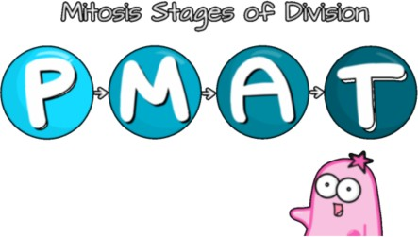**Directions:** We encourage you to be creative with a cartoon illustration of your own for each phase. Label the **chromosomes**, **spindles**, and **nucleus** (if applicable).

|  |  |
| --- | --- |
| **Prophase** | **Metaphase** |
| **Anaphase** | **Telophase** |

